**Mauritania country profile**

Published

19 February 2018

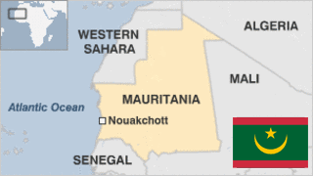

**One of Africa's newest oil producers, the Islamic Republic of Mauritania bridges the Arab Maghreb and western sub-Saharan Africa.**

The largely-desert country presents a cultural contrast, with an Arab-Berber population to the north and black Africans to the south. Many of its people are nomads.

In the Middle Ages Mauritania was the cradle of the Almoravid movement, which spread Islam throughout the region and for a while controlled the Islamic part of Spain.

European traders began to show interest in Mauritania in the 15th century. France gained control of the coastal region in 1817, and in 1904 a formal French protectorate was extended over the territory.

Mauritania is rich in mineral resources, especially iron and ore.

It is seen by the West as a valuable ally in the fight against Islamist militancy in the Sahel region.

* Read more [country profiles](http://news.bbc.co.uk/1/hi/country_profiles/) - Profiles by [BBC Monitoring](http://bbc.co.uk/monitoring)

**President: Mohamed Ould Abdel Aziz**

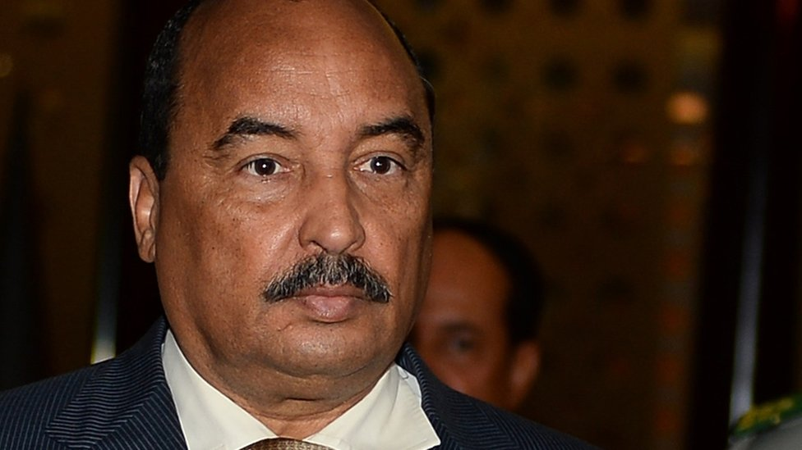image copyrightAFP

Mohamed Ould Abdel Aziz took power in a coup in 2008, and was elected president the following year.

He gained another five-year term in June 2014 with almost 82% of the vote in an election boycotted by most of the opposition.

He is a key ally of the West and neighbouring states in countering Islamist extremist groups.

* Voters in a constitutional referendum in August 2017 endorsed the president's proposals to scrap the Senate and to change the flag. The opposition boycotted the vote, accusing Mr Abdel Aziz of planning to change the constitution so he can stand for a third term. He has denied this.

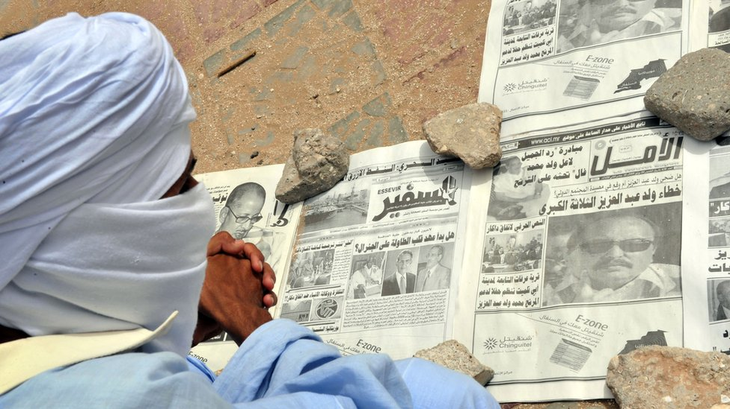image copyrightGetty Images

Mauritania has one of the most open media environments of the Maghreb region.

Internet access is unrestricted, with number of users reportedly exceeding 455,000 by 2014.

# Mauritania profile - Timeline

Published

19 February 2018

**A chronology of key events:**

**3rd-7th centuries AD** - Berber and Arab migrants arrive in present-day Mauritania.

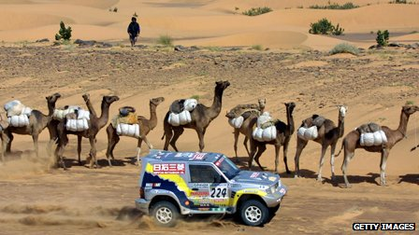image copyrightGetty Images

image captionMauritania formed part of the Paris to Dakar rally before it was moved because of security fears

**9-10th centuries** - Empire of Ghana has its capital in present-day south-west Mauritania.

**1076** - Berber Almoravid warriors defeat the Empire of Ghana.

**1500s** - European mariners and traders establish settlements.

**1644-74** - Mauritanian Thirty-Year War: Berbers unsuccessful in repelling Arab warriors.

**1850s-60s** - French forces gain control of southern Mauritania. In 1898 France wins the allegiance of Moors in the region.

**1904** - France establishes Mauritania as a colonial territory.

**1920** - Mauritania becomes part of French West Africa, and is administered from Senegal.

**1946** - Becomes a French overseas territory.

## Independence

**1958** - Mauritania becomes self-governing.

**1960** November - Mauritania becomes independent.

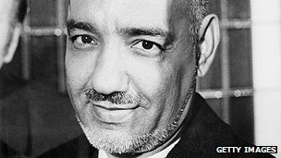image copyrightGetty Images

image captionMauritania's president, Moktar Daddah, was ousted in a coup

**1976** - Mauritania and Morocco divide up Spanish Sahara, now known as Western Sahara, after Spain pulls out. Guerrillas of the Polisario front, aiming to establish an independent state in the territory, fight the forces of both countries.

## Military coup

**1978** - First post-independence president, Moktar Daddah, is deposed in a military coup, prompted partly by pressure of Polisario campaign.

**1979** - Mauritania signs a peace agreement with the Polisario front and renounces its claim to Western Sahara. Morocco annexes Mauritania's former share of the territory.

**1984** - Coup brings Colonel Maaouiya Ould Sid Ahmed Taya to power.

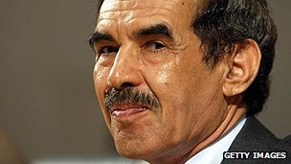image copyrightGetty Images

image captionColonel Ould Taya came to power after a coup, won subsequent elections but was himself ousted by the military

**1989** - Race riots erupt in Mauritania and Senegal after a border dispute. Tens of thousands of black Mauritanians are driven out of the country into Senegal. Others become the targets of attacks and land seizures. Hundreds of people are killed.

**1992** - Colonel Ould Taya elected president.

**1993** - US ends development aid over Mauritania's treatment of its black population and its support for Iraq in the 1991 Gulf War.

**1997** - President Ould Taya re-elected in a poll boycotted by the main opposition parties.

**2002** January - Opposition party Action for Change, which campaigns for greater rights for blacks and descendants of slaves, is banned.

## Coup plots

**2003** June - Attempted coup: Troops loyal to President Ould Taya regain control of the capital after heavy fighting with rebel soldiers.

**2003** November - President Ould Taya re-elected with 67% of vote in first round of elections. Opposition alleges fraud.

**2004** September - Government says it has foiled a coup plot - the third in 15 months. In October President Taya accuses Libya and Burkina Faso of financing recent coup attempts.

**2005** January - UN calls for food aid in the wake of locust invasions in 2004. Mauritania was the African country worst hit, with its crop production obliterated.

**2005** August - With President Ould Taya out of the country, troops seize government buildings and a group of officers announces the overthrow of the president and the formation of a military council.

**2006** February - Offshore oil production begins.

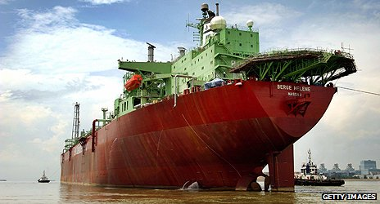image copyrightGetty Images

image captionA tanker leaves the Mauritanian port of Chinguitti to take on oil from offshore fields which started production in 2006

**2006** June - Voters in a referendum approve constitutional changes which will limit the president to two five-year terms in office.

## Abdallahi elected president

**2007** March - Presidential elections won by Sidi Ould Cheikh Abdallahi.

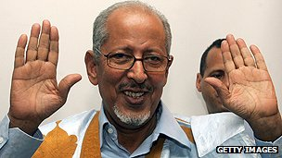image copyrightGetty Images

image captionSidi Ould Cheikh Abdallahi won elections in 2007 but was ousted in a coup the following year

**2007** April - Mauritania is readmitted to the African Union, having been suspended after the 2005 coup.

**2007** August - Parliament outlaws slavery, a practise still widespread in spite of a 1981 ban.

**2008** January - The 2008 Dakar Rally is cancelled following the murder of four French tourists in Mauritania in December, allegedly by attackers linked to al-Qaeda.

**2008** April - Eight al-Qaeda suspects alleged to have been involved in killing of French tourists and attack on Israeli embassy are arrested.

**2008** May - Members of moderate Islamist opposition party join government for first time.

## Abdallahi toppled

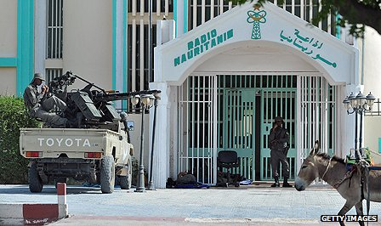image copyrightGetty Images

image captionTroops stand guard after taking over the state radio during the 2008 coup

**2008** August - The military overthrows President Abdallahi - the country's first democratically elected leader - and forms a state council to rule the country. The move came after the president tried to dismiss several senior army commanders.

**Al-Qaeda activity**

**2009** July - Gen Mohamed Ould Abdel Aziz - leader of the August 2008 military coup - wins presidential elections.

**2010** April - Mauritania, Mali, Niger and Algeria set up joint command to tackle threat of terrorism.

**2010** August - Two Spanish aid workers kidnapped in Mauritania by al-Qaeda in November are set free in Mali after nine months in captivity.

**2011** November - Government approves new radio and TV stations following an announcement of media liberalisation.

**2012** January - Malian refugees stream into Mauritania over several months, fleeing a Tuareg rebellion in the north of their country.

**2012** April - Public burning of religious texts allegedly condoning slavery sparks widespread controversy. Abolitionist leader Biram Ould Abeid is detained.

**2013** December - President Ould Abdel Aziz's Union for the Republic party wins a majority of seats in the first parliamentary polls since 2006. The vote was boycotted by most opposition groups.

**2014** June - President Ould Abdel Aziz wins another five-year term in elections boycotted by the opposition.

**2014** July - France announces establishment of a long-term military operation aimed at preventing jihadist groups from establishing safe havens in the Sahel, including Mauritania.

**2014** December - A blogger, Mohamed Cheikh Ould Mohamed, is sentenced to death for supposed blasphemy against the Muslim prophet, Muhammad. He awaits the decision of the Supreme Court.

**2015** January - Three activists, including former presidential candidate Biram Ould Abeid, are sentenced to two years in prison for their part in anti-slavery protests.

**2017** August - Voters in a referendum endorse the president's plan to scrap the Senate and change the flag.